DAY 33 REPORT
TASK NAME : Exploring and Performing Calculations Using Quick Measures in Power BI

OBJECTIVE
The objective of this task is to explore the Quick Measures feature in Power BI and understand how various calculations can be created automatically without manually writing DAX formulas. The task focuses on performing category-based, filter-based, and customer-based calculations using a healthcare dataset.

INTRODUCTION
Quick Measures in Power BI provide predefined calculation templates that automatically generate DAX formulas based on user-selected fields. They help users perform advanced analytical calculations quickly and accurately without requiring extensive knowledge of DAX. Quick Measures are useful for creating summaries, comparisons, rankings, percentages, and time-based calculations for data analysis and reporting.

DATASET DESCRIPTION
The Healthcare Dataset contains patient-related information such as:
- Name
- Age
- Gender
- Blood Type
- Medical Condition
- Date of Admission
- Doctor
- Hospital
- Insurance Provider
- Billing Amount
- Room Number
- Admission Type
- Discharge Date
- Medication
- Test Results
The dataset was used to perform and analyze various Quick Measure calculations in Power BI.

TASK PERFORMED
- Imported the healthcare dataset into Power BI.
- Explored the Quick Measures feature.
- Created multiple Quick Measures using different fields from the dataset.
- Analysed the automatically generated DAX formulas.
- Added the calculated measures to visualizations for better understanding.
- Compared the outputs generated by different Quick Measure categories.

QUICK MEASURES CREATED
1. Average per Category
Calculated the average value of a measure for each category.
Example:
- Base Value: Age
- Category: Gender
Purpose:
To compare the average age of patients across different genders.
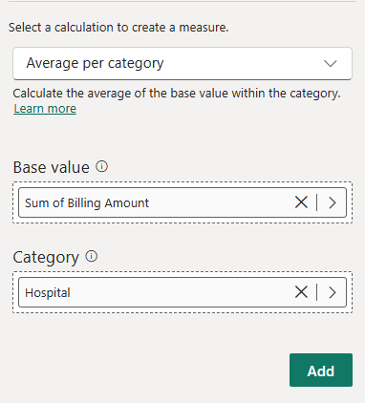

2. Variance per Category
Calculated the variation of values within categories.
Example:
- Base Value: Billing Amount
- Category: Insurance Provider
Purpose:
To analyse differences in billing amounts among insurance providers.
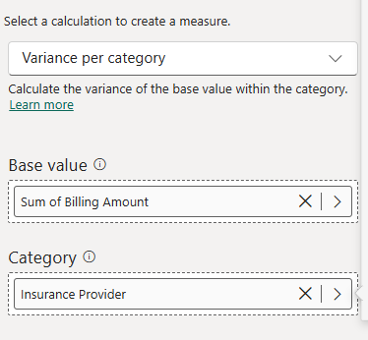

3. Maximum per Category
Calculated the highest value within each category.
Example:
- Base Value: Age
- Category: Blood Type
Purpose:
To identify the maximum patient age for each blood group.
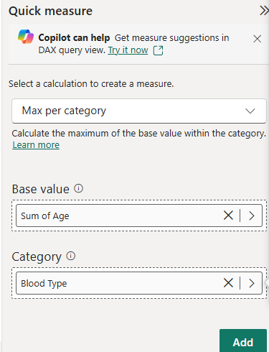

4. Minimum per Category
Calculated the lowest value within each category.
Example:
- Base Value: Billing Amount
- Category: Medical Condition
Purpose:
To determine the minimum billing amount associated with each medical condition.
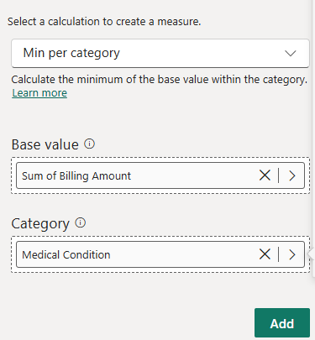

5. Weighted Average per Category
Calculated an average considering the weight assigned to values.
Example:
- Base Value: Billing Amount
- Category: Admission Type
Purpose:
To obtain a more representative average based on weighted values.
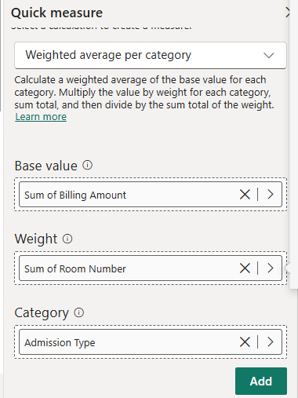

6. Filtered Value
Calculated values based on applied filters.
Example:
- Base Value: Billing Amount
- Filter: Hospital
Purpose:
To analyse billing amounts after applying specific filters.
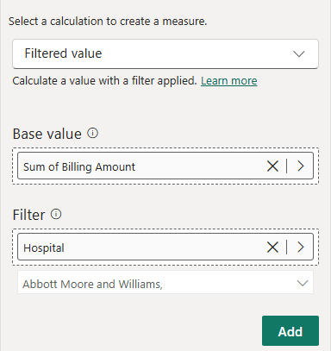

7. Difference from Filtered Value
Calculated the difference between current and filtered values.
Example:
- Base Value: Age
- Category: Gender
Purpose:
To compare category values against filtered results.
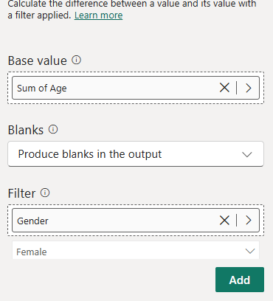

8. Percentage Difference from Filtered Value
Calculated percentage variation between filtered and current values.
Example:
- Base Value: Billing Amount
- Category: Insurance Provider
Purpose:
To understand relative differences between categories.
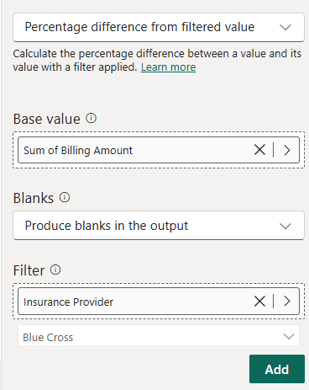

9. Sales from New Customers
Calculated revenue generated from newly acquired customers.
Purpose:
- Tracks revenue from first-time customers.
- Evaluates customer acquisition performance.
- Measures growth contributed by new customers.
Observation:
Although the healthcare dataset does not contain a dedicated customer field, this Quick Measure was explored to understand its functionality and the DAX formula automatically generated by Power BI.
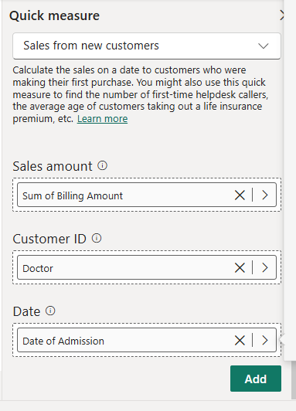

OBSERVATIONS
- Quick Measures automatically generated DAX expressions.
- Advanced calculations were created without manually writing DAX code.
- Different analytical calculations could be performed quickly.
- Category-based and filter-based analysis became easier.
- The feature improved productivity and reduced development time.

RESULT
Successfully explored and implemented various Quick Measures including Average per Category, Variance per Category, Maximum and Minimum per Category, Weighted Average, Filtered Values, Difference Calculations, Percentage Difference Calculations, and Sales from New Customers. The generated measures were used to analyse healthcare data effectively.
CONCLUSION
Quick Measures provide an efficient way to create complex calculations in Power BI without extensive DAX knowledge. Through this task, multiple Quick Measure categories were explored and analysed using a healthcare dataset. The feature simplified data analysis, improved reporting efficiency, and enhanced understanding of automated calculations in Power BI.

